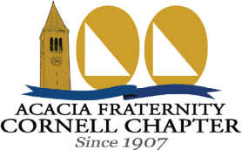
Donation Guide
Centennial Capital Campaign
(Revised 7/29/2007)

Thank you for considering a gift to the Centennial Capital Campaign. Your financial support will allow us to undertake several valuable projects, such as installing a sprinkler system, completing overdue maintenance, revitalizing the chapter house’s library room, and growing our Acacia Fraternity Foundation chapter account. We use our Foundation account to fund educational expenses, leadership development activities, and scholarships. For more information about the Acacia Fraternity Foundation, visit: www.acacia.org/aff_main.htm (note the underscore in “aff_main”).

This Donation Guide contains instructions for filling out your Donation Pledge Form and provides general information pertaining to your donation, such as payment logistics and details about tax deductibility. We recommend that you save the guide for future reference, since it will remind you of relevant information when you make later payments.

Donation Pledge Form—Instructions and Explanations:

Name:

- Please write your name exactly as it should appear on our donor recognition plaque in the chapter library and in Campaign publications.

Table Describing Your Giving Plan:

- Please let us know when you plan to make payments and how you plan to split each payment between the chapter’s Alumni House Corporation and our Acacia Fraternity Foundation chapter account.

- Donations to the House Corporation are not tax deductible, but donations to the Foundation are tax deductible. We recommend contributing to the Corporation, since most of our planned projects, including the sprinkler system, do not qualify for Foundation funding. However, if you can receive a matching donation from your employer, or if you strongly prefer to give only on a tax deductible basis, we would be grateful to receive your contribution to the Foundation.

- If you will be 70½ by the end of 2007, you may be eligible to make your contribution as a one-time tax-free distribution from your IRA. Please contact us for more information on how to do this.

Anonymity:

- If you check the box indicating that your donation should remain anonymous, we will not list your name on the donor recognition plaque, in the Traveler, on the Campaign’s web site, or in other Campaign materials.

Recognition Gifts:

- Based on your total donation amount, you are entitled to receive certain recognition gifts as a token of our appreciation. Please check the boxes on the form corresponding to the gifts you would like.

- All donors are eligible to receive a hardcover copy of Acacia Fraternity at Cornell: The First Century. We highly recommend that you opt to receive the book, unless you have otherwise procured a copy. It provides a fascinating view into the chapter’s history, and reflects countless hours of work by its author, Thomas Balcerski ’05 (#1063).

- Donors pledging at least $1,000 may also be entitled to a combination of the following items: Centennial Polo Shirt, Centennial T-Shirt, and Centennial Mug (see descriptions below). Please select from among these gifts according to the following guidelines:
Total Donation:
$10,000 or more
$5,000 - $9,999
$2,500 - $4,999
$1,000 - $2,499
Gift Eligibility:
Choose up to three items
Choose up to two items
Choose any one item
Choose either a Centennial T-Shirt or Mug

- We will mail your gifts to you after we have received your first payment.

- If you elect to receive any recognition gifts, the amount of your Foundation donation that we can recognize as tax deductible will decrease by the value of the gifts (in proportion to the percentage of your total planned donation you have designated for the Foundation). Your first payment to the Foundation will absorb the reduction. Gift values are listed below.

- Example: You plan to give $2,500 total over the Campaign’s five years, $500 each year, with half of the total ($1,250) going to the Corporation and half ($1,250) to the Foundation. Assuming that you receive recognition gifts totaling $40 in value, half of their value ($20) will reduce the tax deductible amount of your first payment to the Foundation. The Foundation will recognize a tax deductible donation of $230 in the first year and $250 in each subsequent year.

Acacia Apparel and Collectible Items
Centennial T-Shirt
Screen Printed
100% Cotton
Gift Value: $18.00
(add $2.00 for XXL)
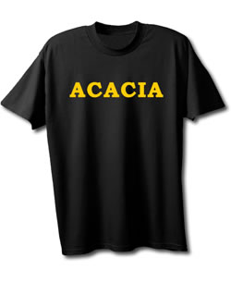
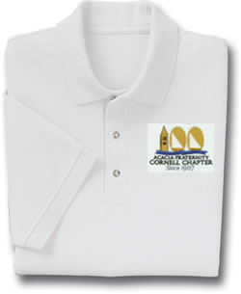
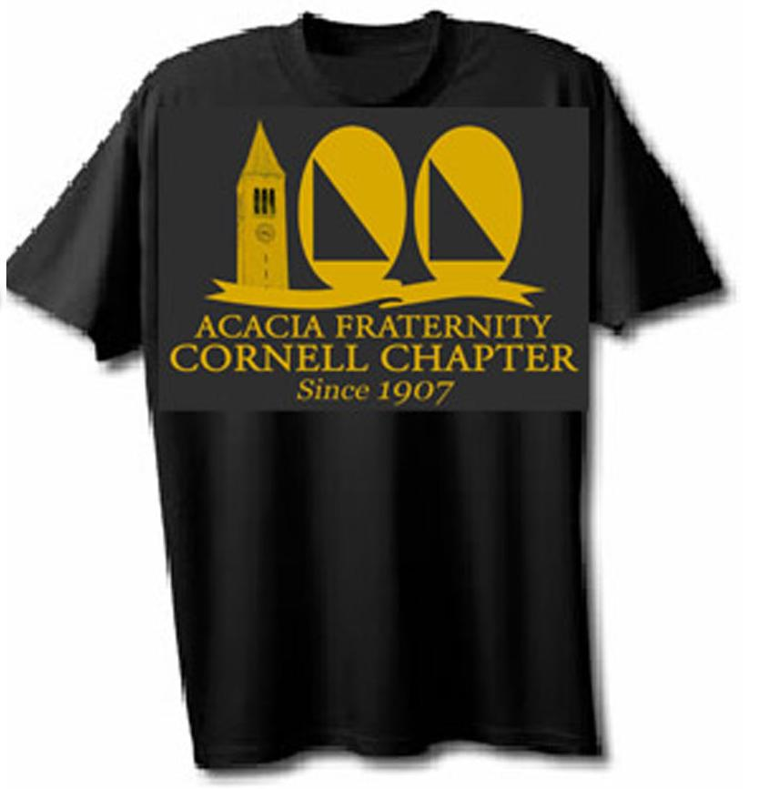
Centennial Polo Shirt
Embroidered Design
65% Poly/35% Cotton Blend
Gift Value: $30.00
(add $2.00 for XXL)

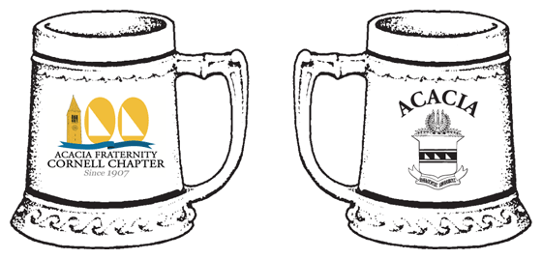
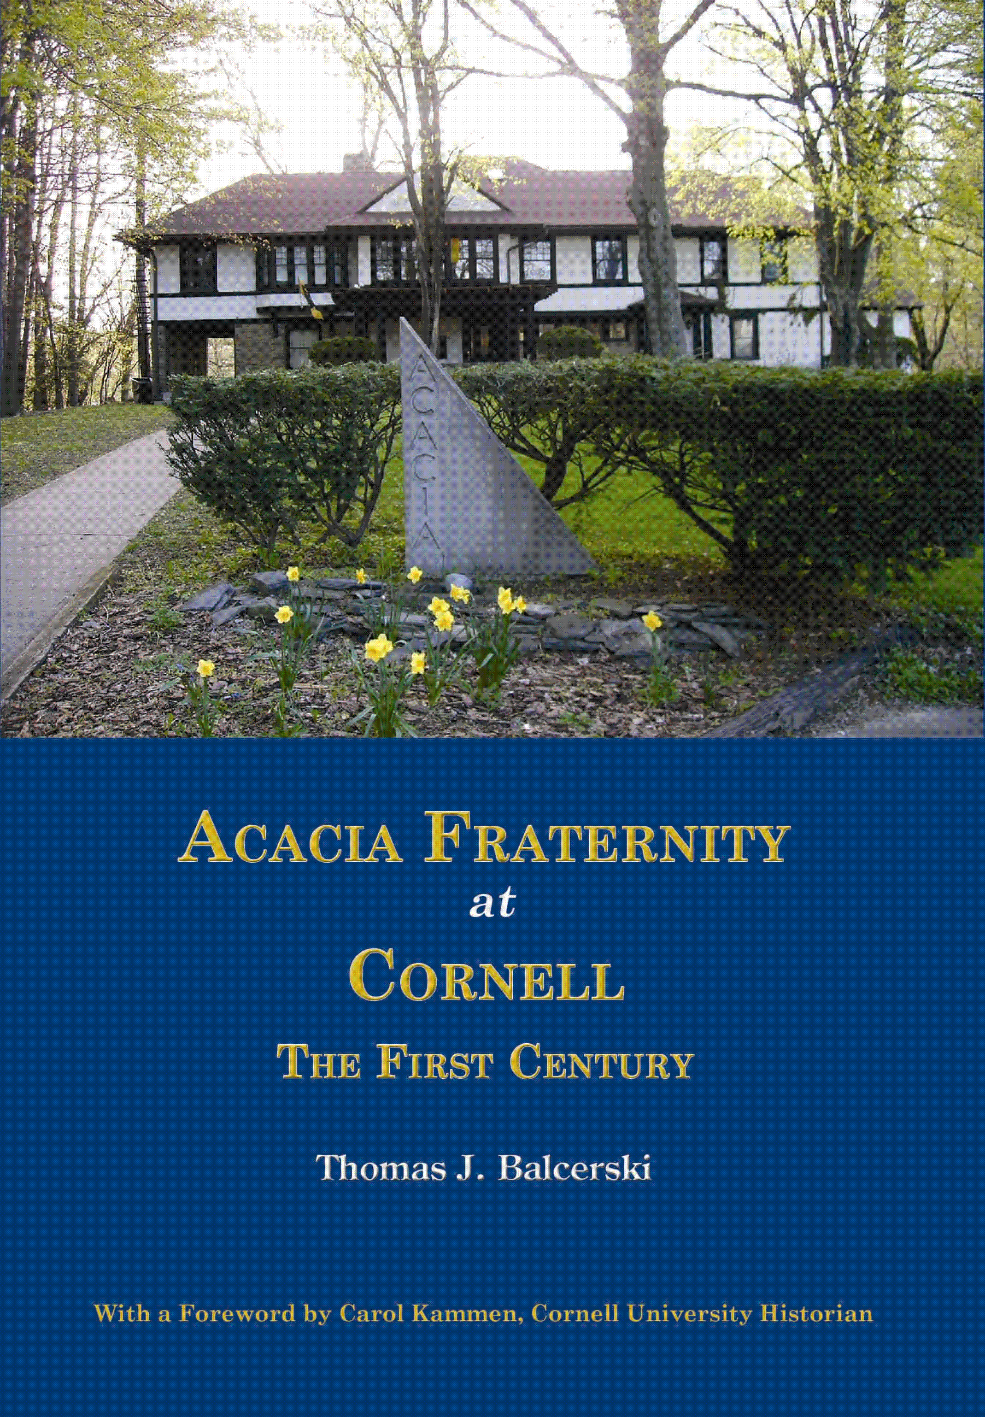
Chapter History Book
Hardcover, Over 300 Pages 250 Previously Unreleased
Photographs and Illustrations
Complete Chapter Roll
Gift Value: $30.00
Centennial Mug
Size: 28 fl. oz.
Gift Value: $20.00

First Payment:

- If paying by check, please enclose your 2007 payment when you mail in your pledge form. Make checks payable to “Acacia Fraternity, Inc.” Please be sure that your completed form shows the amounts designated for (i) the Corporation and (ii) the Foundation. Regardless of how you want to divide your donation, you may send a single payment to the Corporation in Ithaca, and we will forward the indicated amount to the Foundation for you.

- If you opt to pay online via PayPal, please also send your completed form to us. We will need the information on the form to determine how to allocate your PayPal payment between the Corporation and the Foundation.

- If your entire payment is designated for the Foundation, you may send a check directly to the Foundation at the address on the following page. Make checks payable to “Acacia Fraternity Foundation” and indicate “Cornell Chapter Account” in the memo. Again, please mail your pledge form to the chapter house so that we have relevant information about your giving plans on file.

- If you plan to contribute from your IRA, please indicate this on your pledge form but DO NOT include a check. Your payment must transfer directly from your IRA administrator to the Foundation. We will contact you with eligibility information and payment instructions.

Submitting Your Form:

- Please mail your completed pledge form, along with your 2007 payment if paying by check, to:

Acacia Fraternity
c/o Alumni Affairs
318 Highland Road
Ithaca, NY 14850

- Before submitting the form, please make a copy for your records. Thank you!

General Information:

Payment Timing:

Over the Campaign’s five-year horizon, we will send you an annual reminder with the Fall Traveler each year from 2008 through 2011.

Payment Logistics:

Each year, you may send a single check or PayPal payment to the House Corporation in Ithaca. The Corporation will retain its designated portion of the payment, and then send the remainder to the Acacia Fraternity Foundation’s office in Indianapolis. The Foundation will send you a letter acknowledging receipt of your tax deductible donation, less any applicable reduction due to recognition gifts you have chosen to receive. These letters will serve as documentation to the IRS that you made a tax deductible donation to a charitable organization.
Every time you make a payment, you will also need to return the reminder form we send you to indicate how to divide your payment between the Corporation and the Foundation.

PayPal:

You may make payments via PayPal at the chapter’s web site, www.cornellacacia.org. We have included this option for your convenience, but please be aware that PayPal will take 3% of your donation in fees. If you make a payment with PayPal instead of writing a check, the Foundation will still recognize a tax deductible donation of the full amount (less the applicable portion of any recognition gifts). However, the chapter will only receive 97% percent of the value of your gift.

Corporate Matching Donations:

If your employer sponsors a matching program for philanthropic donations, we invite you to take advantage of this opportunity. Our Foundation’s tax ID number is 351778332. Please contact the Foundation if you or your employer needs more information.

Tax Deductibility:*
*Please consult your tax advisor about the tax implications of your donation

Below is a brief summary of tax-related information that other Campaign literature has mentioned:

- Donations to the Corporation are not tax deductible, but donations to the Foundation are tax deducible.

- Each time you make a payment, the Foundation will send you a letter acknowledging receipt of any tax deductible portion. You can use this letter as documentation to the IRS that you made a charitable donation. Regardless of whether you mail in a check or use PayPal, the Foundation will recognize the same amount as tax deductible.

- The Campaign Committee will also send you letters acknowledging receipt of your payments. DO NOT use these letters as proof of any tax deductible donations to the Foundation. Instead, only use letters from the Foundation as evidence that you made tax deductible contributions.

- If you choose to receive any recognition gifts, the tax deductible amount of your first payment to the Foundation will decrease by a percentage of the gifts’ value. The Foundation’s acknowledgement letter for your first payment will reflect the decrease.

Contact Information: (Campaign Committee is the preferred point of contact)
Acacia Fraternity Foundation:
8777 Purdue Road, Suite 225
Indianapolis, IN 46268
Phone: (888) 345-1904
Web: www.acacia.org

Campaign Committee:
Bradley Ayres ’06 (#1070)
Phone: (607) 731-9338
Email: bja27@cornell.edu

Cornell Acacia:
318 Highland Road
Ithaca, NY 14850
Phone: (607) 257-7055
Web: www.cornellacacia.org

Thank You For Your Generosity!

